**Self-Intensive Training on Full Stack Development**

**Student Name:** Vimal Kumar P S

**Register Number:** 7376221EC342

**Seat No:** 429

**Project ID:** 29

**Project Title:** BIT- Interview Candidates Details

**Domain:** Training & Placement (T&P)

**Problem Statement:**

Currently, the process of managing hired candidate information is inefficient and often relies on manual methods such as spread sheets or paper files. This can lead to several problems:

* **Data Inaccuracy:** Manual data entry is prone to errors, resulting in inaccurate candidate information.
* **Difficulty in Accessing Information:** Retrieving specific candidate details can be time-consuming when using scattered documents or spread sheets.
* **Lack of Collaboration:** Sharing information and tracking the hiring process across different teams can be challenging.
* **Inefficient Communication:** Sending interview notifications, offer letters, and other communication can be cumbersome with manual processes.
* **Limited Data Analysis:** Gaining insights into hiring trends and identifying areas for improvement can be difficult without proper data collection and reporting.

To address these issues, we propose developing a dedicated website for managing all aspects of the candidate information. This system will provide a centralized platform for storing, accessing, and maintaining candidate information, streamlining the hiring process and improving overall efficiency.

**Project Description:** Developing a website to easily access and maintain the following details of hired candidates: Name, Year of passing, Gender, Branch and Degree, Educational Details, Contact Number, Resume Upload, Designation, Date of Interview, Selection status, Date of Joining, Photo, Working status and Address.

**Project Requirements:**

**1. User-friendly Interface:** Design and develop an intuitive and visually appealing interface that allows admin and employers to navigate through the website with ease

**2. Candidate Details Management:** Implement a robust system to store and manage candidate information, including Name, Year of passing, Gender, Branch and Degree, Educational Details, Contact Number, Resume Upload, Designation, Date of Interview, Selection status, Date of Joining, Photo, Working status, and Address.

**3. Search and Filter Functionality:** Enable admin to search and filter candidates based on specific criteria such as name, educational qualifications, branch, degree, and more, to quickly identify suitable candidates for their requirements.

**4. Selection and Joining Status Tracking:** Maintain a record of the selection status and date of joining for each candidate to monitor the progress of the hiring process.

**5. Secure and Scalable Database:** Implement a secure and scalable database to store all candidate information, ensuring data privacy and easy expansion as the number of candidates grows.

**6. Responsive Design:** Optimize the website for various devices, including desktops, laptops, tablets, and smartphones, to cater to a diverse user base.

**7. User Authentication and Authorization:** Incorporate a user authentication and authorization system to ensure that only authorized admin can access, modify, and delete candidate information.

**8. Regular Updates and Maintenance:** Develop a system to facilitate regular updates and maintenance of candidate information, ensuring the website remains relevant and accurate.

**9. Accessibility:** Ensure the website adheres to web accessibility standards, making it accessible only to admin with disabilities or special needs and the user can only view their profile in the dashboard.

**Technical Components:**

|  |  |
| --- | --- |
| **Component** | **Tech Stack** |
| Frontend | * HTML * CSS * JavaScript |
| Backend | * Linux * Apache Web Server * PHP with Laravel framework |
| Database | * MySQL |
| API | * REST Ful services |

**Project workflow:**

1. **User Management:**

* **Account Creation:** Authorized personnel (admin) create accounts with secure login credentials.
* **Access Levels:** The system assigns different access levels based on user roles (e.g., Admin can view and edit & User can only view their own profile).

**2. Candidate Entry:**

* **Manual Entry:** Admin manually enter candidate details like name, contact information, educational background, etc.
* **Resume Upload:** Candidates can upload their resumes directly through the website during the application process (if applicable).

**3. Candidate Management:**

* **Search & Filter:** Admin can search and filter candidates based on various criteria (e.g., skills, experience, designation).

**4. Selection Process:**

* **Selection Status:** Update candidate profiles with selection status throughout the hiring process (e.g., Applied, Interview Scheduled, Selected or Rejected).
* **Offer Management:** The system may facilitate generating and sending offer letters with customizable templates.

**5. On-boarding:**

* **Joining Information:** Update candidate profiles with joining date, designation, and other on-boarding details.
* **Document Collection:** Collect and store on-boarding documents like signed contracts, background verification results, etc. within the profile.

**6. Reporting & Analytics:**

* **Candidate Tracking:** Generate reports to track candidate flow throughout the hiring process (e.g., time to hire, source of applications).
* **Performance Analysis:** Analyze hiring trends and identify areas for improvement.

**. Security & Compliance:**

* **Data Encryption:** Implement data encryption practices to protect sensitive candidate information.
* **Compliance:** Ensure the website adheres to relevant data privacy regulations.

**Flowchart:**

If id==admin

**Start**

**Login**

**Invalid user id**

False True

**Open Admin Page**

Personal Details

**Database**

**Monitor and access**

**Update or edit settings**

**Add Candidate**

**Exit**

**Logout**

Educational Details

Working Details

**Adding a candidate:**

* Year of passing
* Degree
* Branch
* College details
* School details

Educational information

* Name
* Date of Birth
* Address
* email address
* phone number

Personal information

* Fresher/experienced
* Designation
* Year of experience
* Date of joining
* Reasons for leaving

Working experience

Documents

Candidate status

* Resume
* Photo
* Degree certificate
* Account pass-book
* Others
* Selected/rejected
* Designation
* Salary
* Official email id
* Remarks

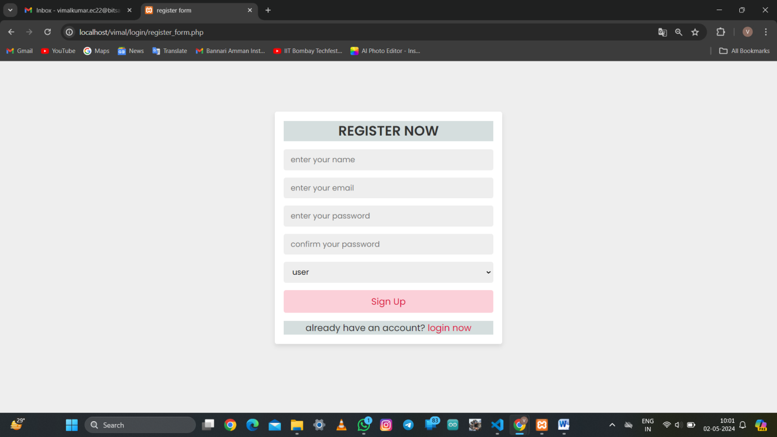**Prototype:**

